Enable SMTP mail with Gmail

Steps to enable SMTP mail with Gmail.

1. Log in to the Gmail account and click on settings as shown below.

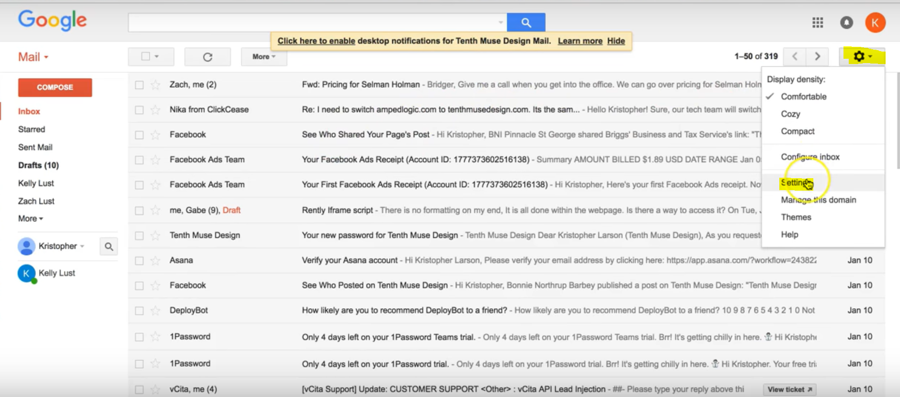

1. After clicking on settings, select Forwarding and POP/IMAP tab.

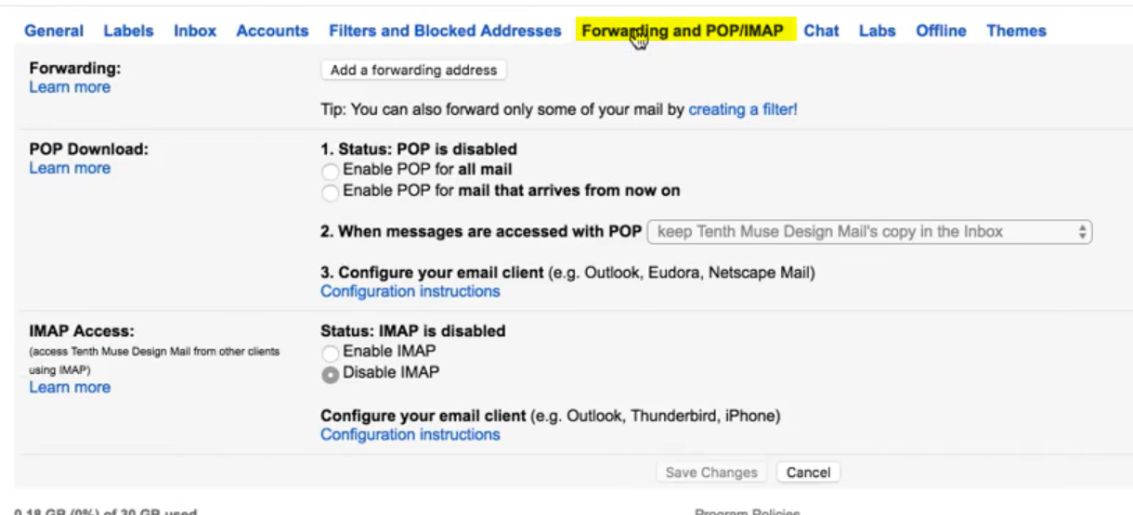

1. Under IMAP Access section, select the **“Enable IMAP”**

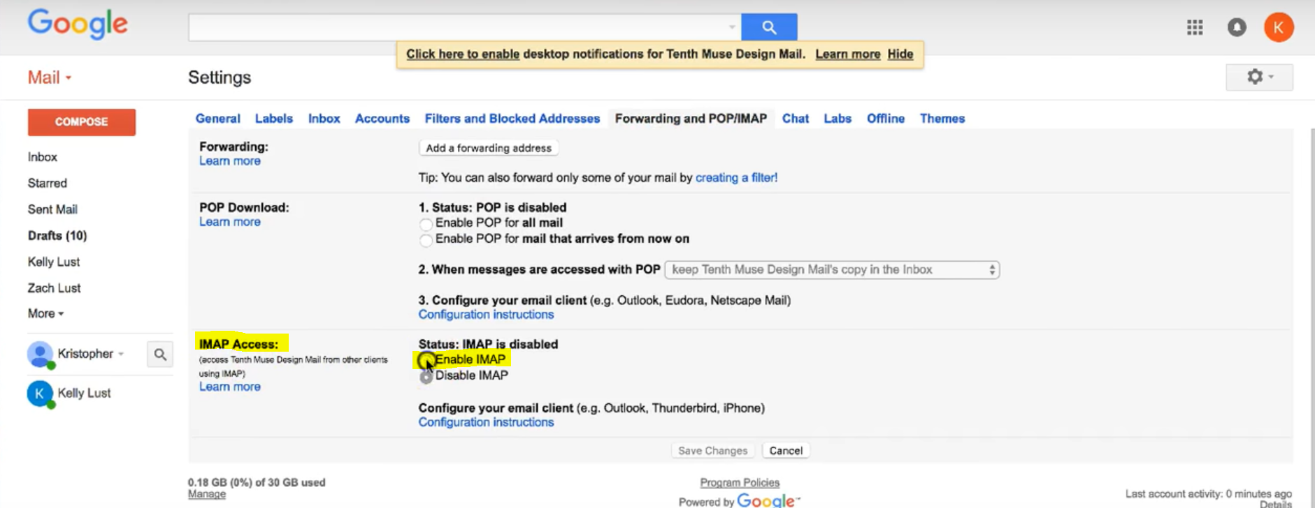

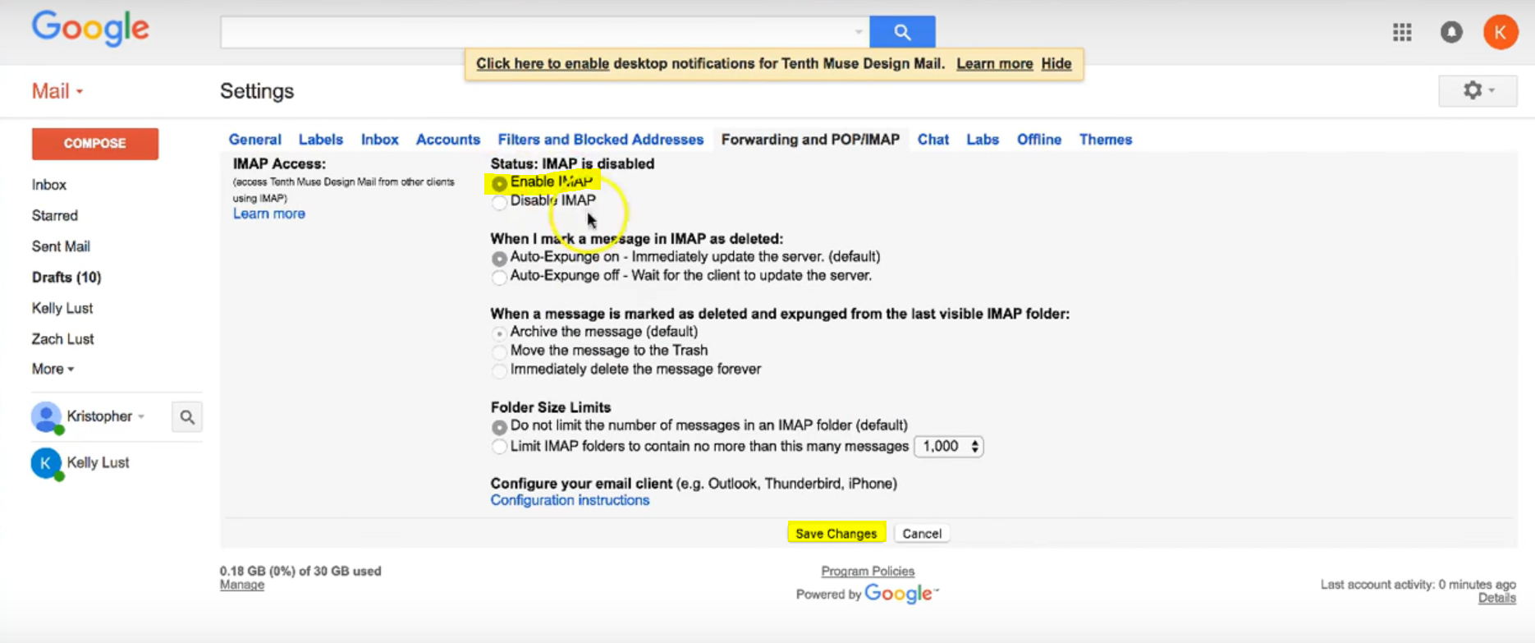

1. Save the changes after making the changes.
2. Click on the profile icon and navigate to Gmail account on clicking **“My Account”** button.

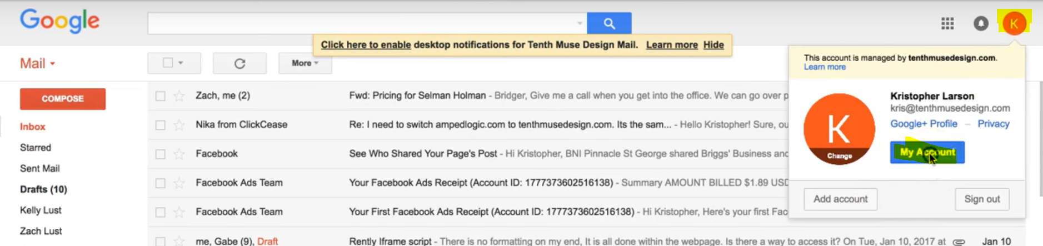

1. Click on Sign-in & security tab.

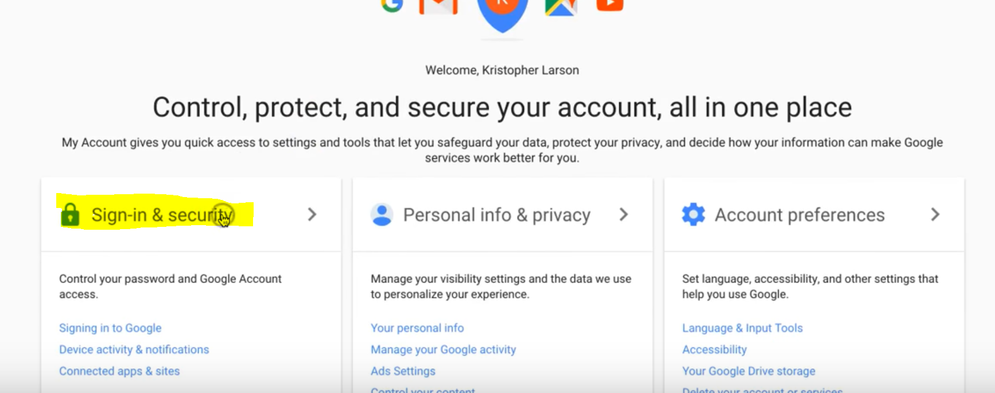

1. Scroll down to bottom and enable **“Allow less secure apps”**

